**Traning Code Explanation.**

**1.This is Library which is used in our Solution.**

import cv2

import numpy as np

from matplotlib import pyplot as plt

import pandas as pd

**2.This is Empty list set.**

list1=[]

list2=[]

list3=[]

**3.We use for loop For Tain Image Dataset.**

**4.We define path for image.**

**5.In next setp we read Image**

**6.we convert image in gray image**

**7. we convert in gaussian image**

**8. we use canny edgae detection.**

**9 In next step we will use Describe function**

**10. we calculate mean median.**

**11. we save in csv file.**

for i **in** range(1,2):

print(i)

path1=str("/kaggle/input/covid19-radiography-database/COVID-19_Radiography_Dataset/COVID")

path2=str("/COVID-")

path3=str(i)

path4=str(".png")

Imagename=path1+path2+path3+path4

print(Imagename)

img = cv2.imread(Imagename,cv2.IMREAD_COLOR)

h, w, c = img.shape

y=int(h*16/100)

x=int(w*16/100)

crop_image = img[x:w,y:h]

*##cv2.imshow('Image',img)*

grayimg = cv2.cvtColor(crop_image, cv2.COLOR_BGR2GRAY)

Gaussian_Iamge = cv2.GaussianBlur(grayimg,(5,5),0)

edges = cv2.Canny(Gaussian_Iamge,30,30)

plt.imshow(edges)

plt.show(block=False)

plt.pause(1)

plt.close()

df = pd.DataFrame(edges/255)

Descibe_Data=df.describe()

Descibe_Data.to_csv('Covid-ROI-Describe-Data.csv')

df1=Descibe_Data.mean(axis=1)

med1=df1.iloc[1:len(df1)].mean(axis=0)

df2=Descibe_Data.median(axis=1)

med2=df2.iloc[1:len(df2)].mean(axis=0)

df3=Descibe_Data.std(axis=1)

med3=df3.iloc[1:len(df3)].mean(axis=0)

list1.append(med1)

list2.append(med2)

list3.append(med3)

list5=sum(list1)/len(list1)

list6=sum(list2)/len(list2)

list7=sum(list3)/len(list3)

list4=['Mean','Median','std']

list8=[round(list5,4),round(list6,4),round(list7,4)]

res = dict(zip(list4, list8))

new = pd.DataFrame.from_dict(res,orient ='index')

new=pd.DataFrame({'Mean' : [list8[0]],

'Median' : [list8[1]],

'Standred Deviation' : [list8[2]] },

columns=['Mean','Median', 'Standred Deviation'])

print(new)

new.to_csv('Covid.csv',index=None)

**Test Code Explanation.**

**In test code step by 10 will be same as Traning code.**

**In next setp we calculate Equlian distance.**

**We save data in csv file for rankig.**

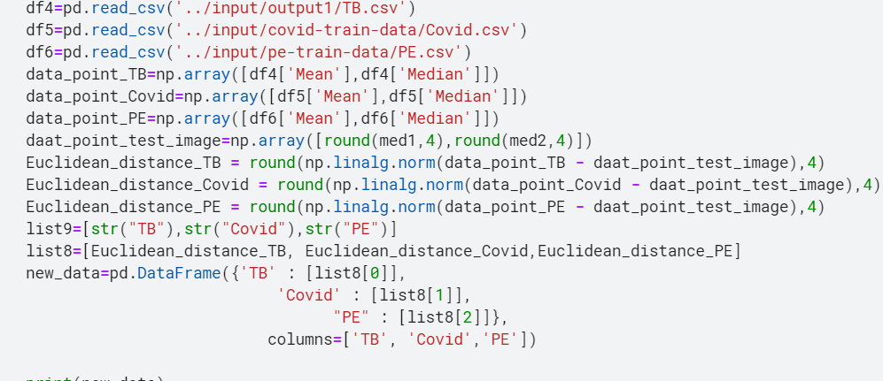

**Automate Word Report**

